**NANDHA ENGINEERING COLLEGE**

**(Autonomous Institution)**

Erode-638 052



**TABLEAU-TWO CREDIT COURSE**

**IV–Semester**

**B.Tech-Artificial Intelligence and DataScience**

**NAME : R.K.SUNIL KUMAR**

**BRANCH : B.TECH AI & DS**

**YEAR : II**

**What is Tableau ?**

**Tableau is a powerful data visualization and business intelligence tool that allows users to connect, visualize, and share data insights in an interactive and user-friendly way. It enables the creation of dynamic charts, graphs, dashboards, and reports through simple drag-and-drop actions, without requiring advanced programming skills. Tableau can connect to a wide variety of data sources, including spreadsheets, databases, and cloud services. It is widely used for data analysis, performance tracking, and decision-making across different industries. Tableau offers several products, such as Tableau Desktop for building visualizations, Tableau Server and Tableau Online for sharing them, and Tableau Public for publishing work publicly.**

**What We Do in Tableau ?**

**In Tableau, we connect to the movie dataset, clean and organize the data, and create visualizations like line charts, maps, pie charts, bar graphs, and treemaps. These visuals are combined into an interactive dashboard to easily analyze trends, distributions, and top-performing movies across different platforms.**

**DashBoard :**

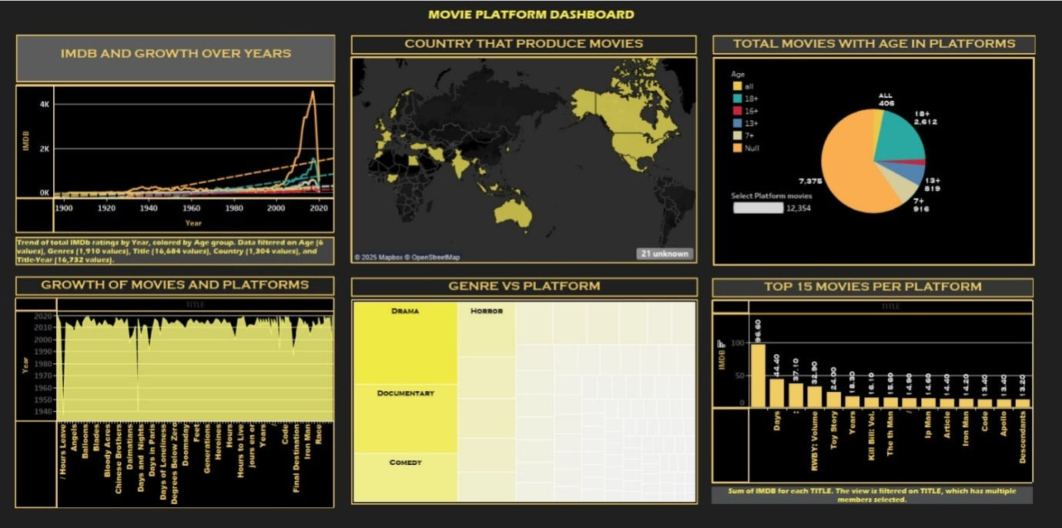

**Contents in Dashboard**

1. **IMDB and Growth Over Years**

**2. Country That Produce Movies**

**3. Total Movies with Age in Platforms**

**4. Growth of Movies and Platforms**

**5. Genre vs Platform**

**6. Top 15 Movies per Platform**

1. **IMDB and Growth Over Years**

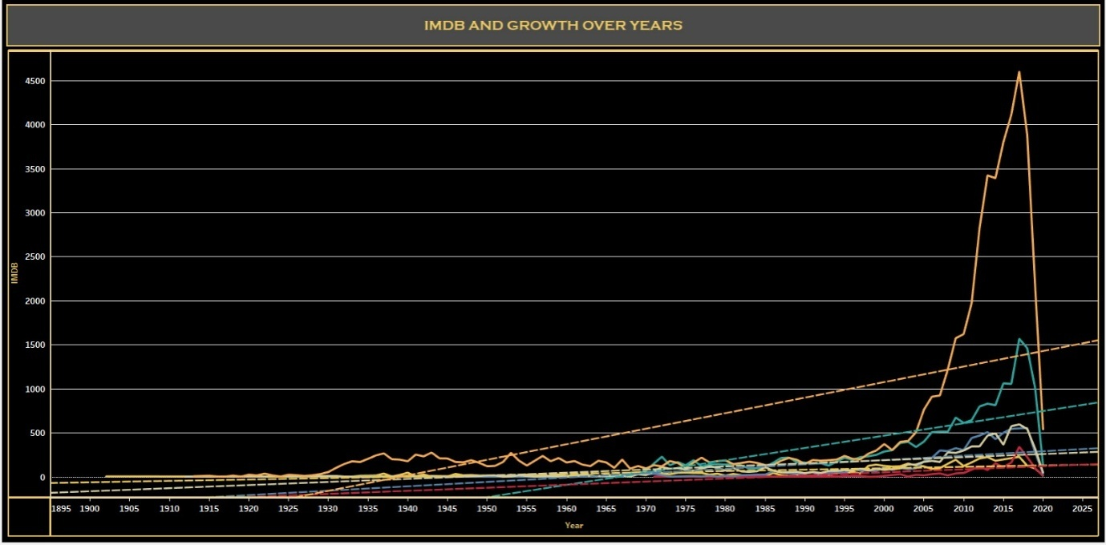

**This line chart shows the trend of total IMDb ratings from 1900 to 2020, categorized by different age groups. It highlights how movie popularity and audience engagement have evolved over time.**

1. 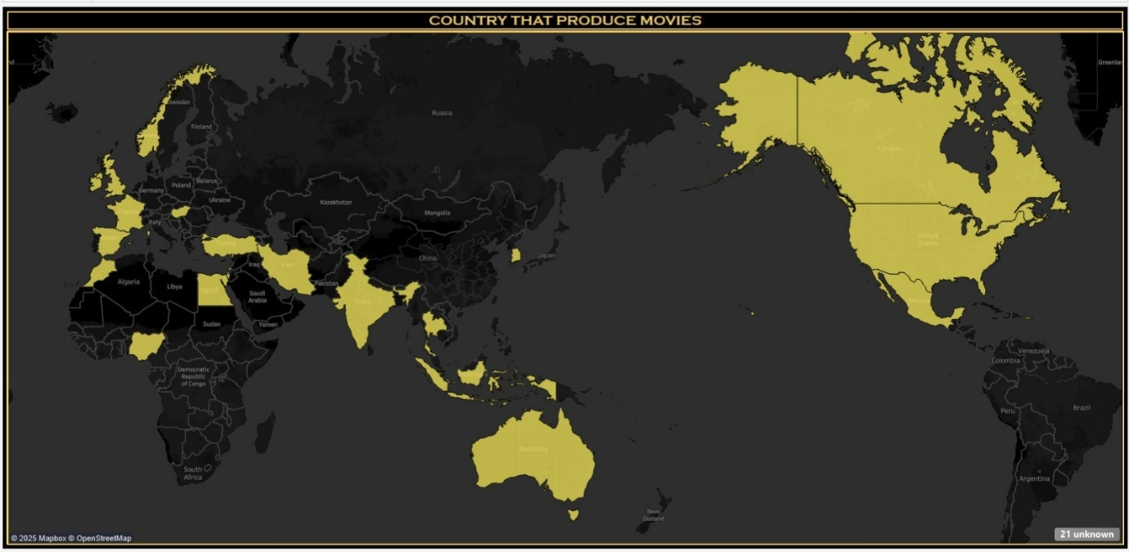**Country That Product Movies**

**This world map displays the countries involved in movie production. Brighter countries indicate higher movie output, helping visualize the global spread of film industries.**

1. **Total Movies with Age in Platforms**

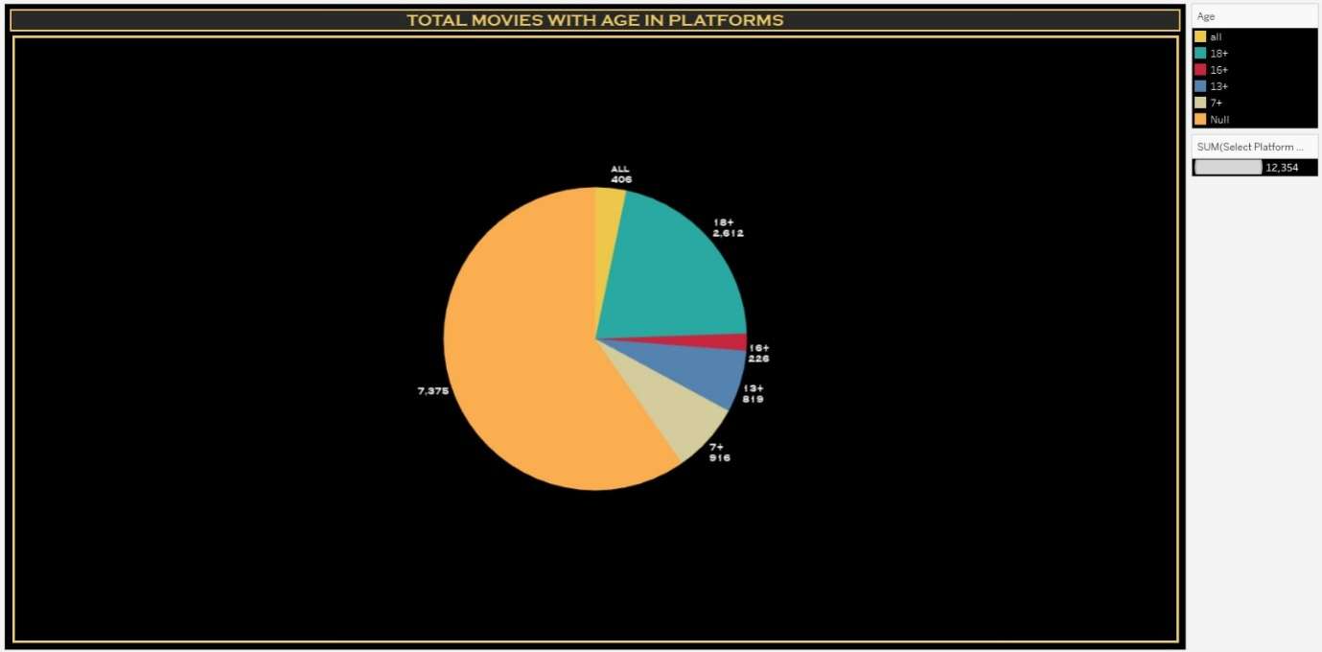

**This pie chart shows the distribution of movies based on age ratings (7+, 13+, 16+, 18+, etc.) across different platforms. It helps understand how content is categorized for different audiences.**

1. **Growth of Movies and Platforms**

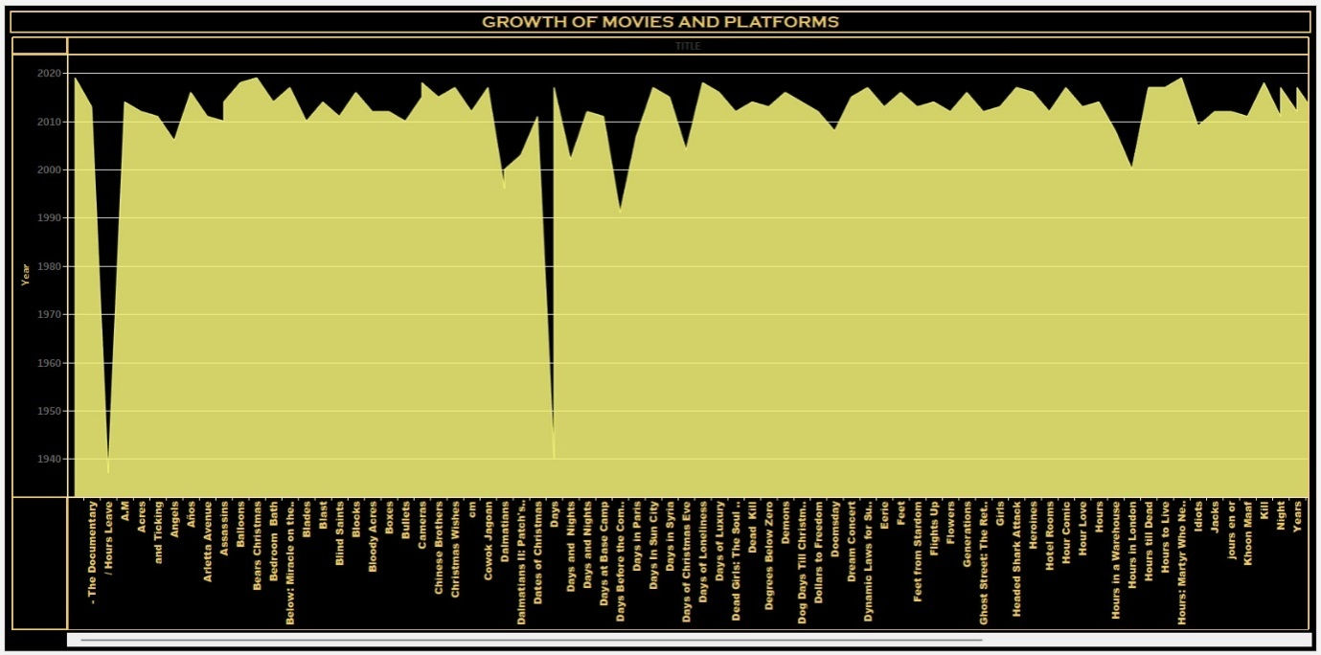

**This bar chart tracks the number of movies available over different years, split by their platforms. It highlights how movie collections have expanded over time on different service.**

1. **Genre vs Platform**

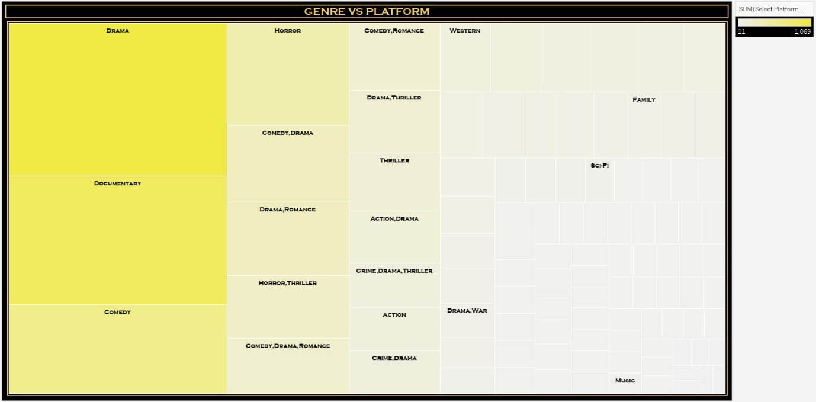

**This treemap illustrates the relation between movie genres (Drama, Horror, Documentary, Comedy, etc.) and the platforms they appear on. Larger blocks represent genres with a higher number of movies.**

1. **Top 15 Movies per Platform**

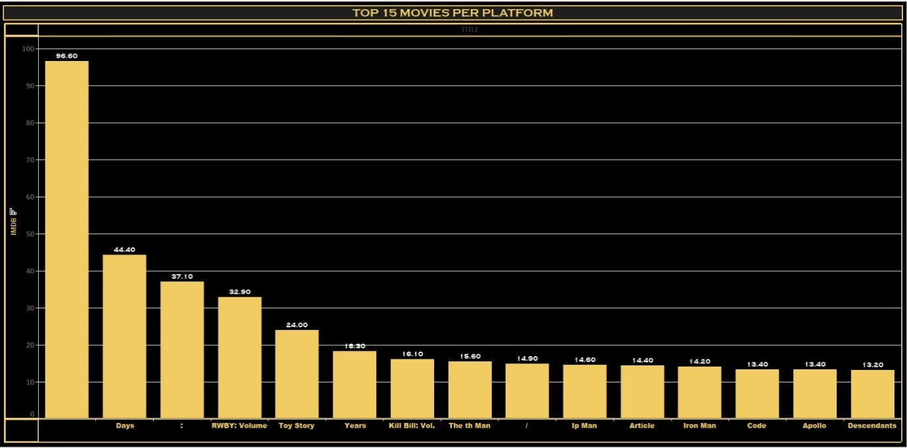

**This horizontal bar chart ranks the top 15 movies based on IMDb ratings across platforms. It identifies the most popular and highly rated movies available.**

**Movie Platform Story – Description**

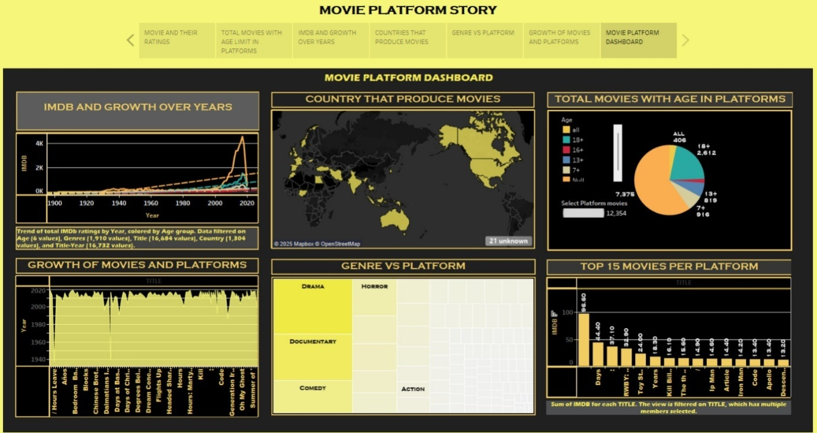

**This story brings together different visual analyses of movies across platforms. It showcases the trends in IMDb ratings over the years, highlights the countries producing the most films, categorizes movies by age ratings, tracks the growth of movies on platforms, maps genres across platforms, and lists the top 15 highest-rated movies.**

**The story is designed to give a complete, interactive view of how movies are distributed, rated, and categorized in modern streaming platforms.**

**Conclusion :**

**The Movie Platform Story provides valuable insights into the evolution of movies across various platforms.By analyzing IMDb ratings, production countries, genre distributions, and audience age categories, we gain a better understanding of movie trends and audience preferences.This interactive dashboard helps identify the most popular movies and highlights the growth of streaming platforms in shaping the global film industry.**